Template – Landing page
Version 24-10-2022
An example: VELUX Commercial CPD
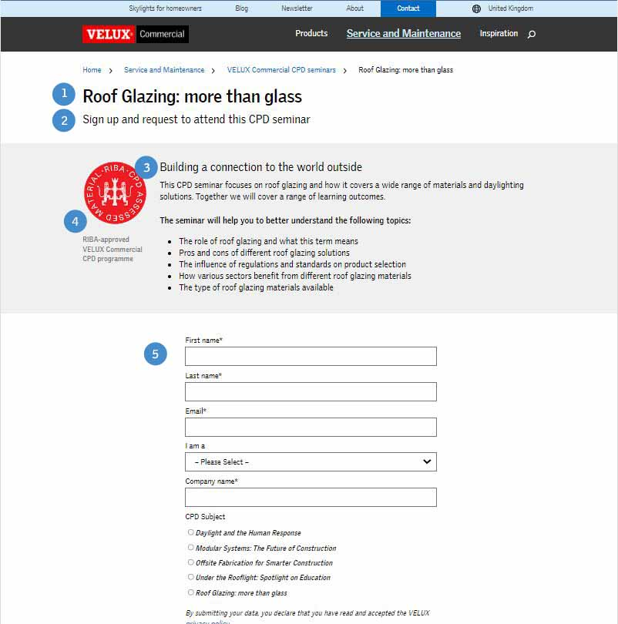
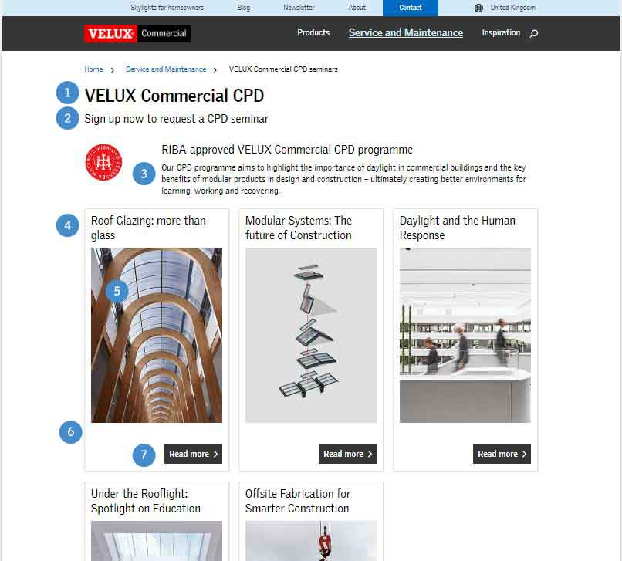
Jumping page Landing page

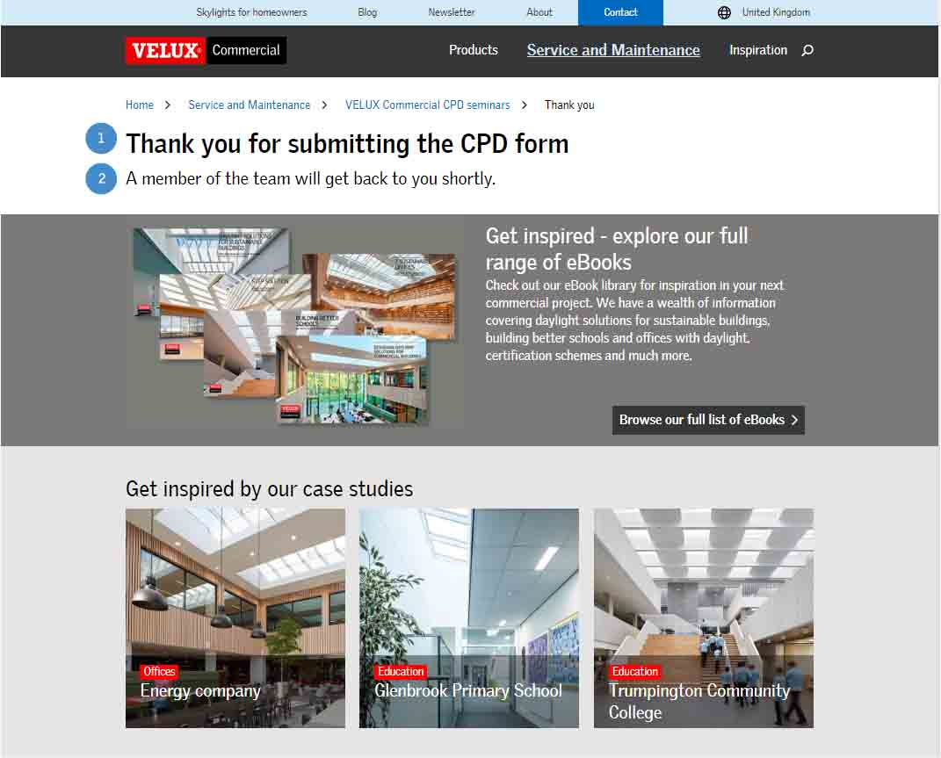
Thank you page

Content for jumping page
Jumping pages help users on our websites navigate to a specific part of our websites (landing pages). Thereby, help users get an overview of what can be found in a particular section of our websites.
1.
Headline:
Describe what can be found in this section of the website
2.
Subheading:
Describe a little more detailed what this section is about
3.
Body text:
Overall information about what can be found in the different landing pages.
4.
Headline for landing page:
Describe in short what can be found in the landing page
5.
Image
WeShare number:
Please provide WeShare number for the image.

Alt-text:
Please provide alt text for the image.
6.
Call to action text:
Short text (a sentence or two) describing what can be found in the landing page
7.
CTA button text:
Text for the button
Title tag:
An ideal length is between 50-65 characters.

See also:
https://commercial.velux.com/digital-guide/titel-tag-and-meta-description

Meta description:
An ideal length is between 140-160 characters. If longer, search engines will cut off the extra characters.

Content for landing page
A landing page is where users “land” after clicking a link. It is typically designed with a specific focus or goal by containing a call to action at the end.
1.
Headline:
Describe what can be found in the landing page (same as nr. 4 in jumping page)
2.
Subheading:
More details about what can be found in the landing page
3.
Body text:
No limitation of characters.

4.
Images:
At least one image, but it would be nice to have more if possible. The images should describe / show what the landing page is about. It is ok to include the image from the jumping page in the landing page as well.

WeShare number:
Please provide WeShare number for all images.

Alt-text / image text:
Please provide alt-text and image text for all images.

Video:
If you include a video, please provide a description of what is shown in the video and a link to the video on WeShare.
5.
Call to action:
There must be at least one call-to-action. No pages should be a dead end for the users.
Title tag:
An ideal length is between 50-65 characters.

See also:
https://commercial.velux.com/digital-guide/titel-tag-and-meta-description

Meta description:
An ideal length is between 140-160 characters. If longer, search engines will cut off the extra characters.

Content for thank you page
1.
Headline:
Short ‘thank you’ sentence.
2.
Subheading:
Sentence describing what the customer can expect now.

